
Marking key

Description |  | Marks
Questioning and predicting
Correctly identifies the variable to be changed (independent variable). | 1
Correctly identifies the variable to be measured (dependent variable). | 1
Correctly identifies at least two controlled variables. |  | 1–2
Subtotal | 4
Writes a question that can be investigated and is reasonable. | 1
Subtotal | 1
Writes a prediction that describes a relationship between the dependent variable and |  | 1–2
the independent variable; and matches the question posed above. |  | 1–2
Provides a reasonable explanation for choosing this prediction. | 1
Subtotal | 3
Planning and conducting
Selects the appropriate equipment required to conduct the investigation. |  | 1–2
Subtotal | 2
Identifies safety risks associated with the investigation. |  | 1–2
Suggests ways to minimise the risks. |  | 1–2
Subtotal | 4

Draws a table that includes:

- descriptive title containing dependent and independent variables

- information relevant to the investigation

- appropriate column headings with units of measurement (if applicable)

1–3

Subtotal

3

Science | Year 8 | Investigation 7

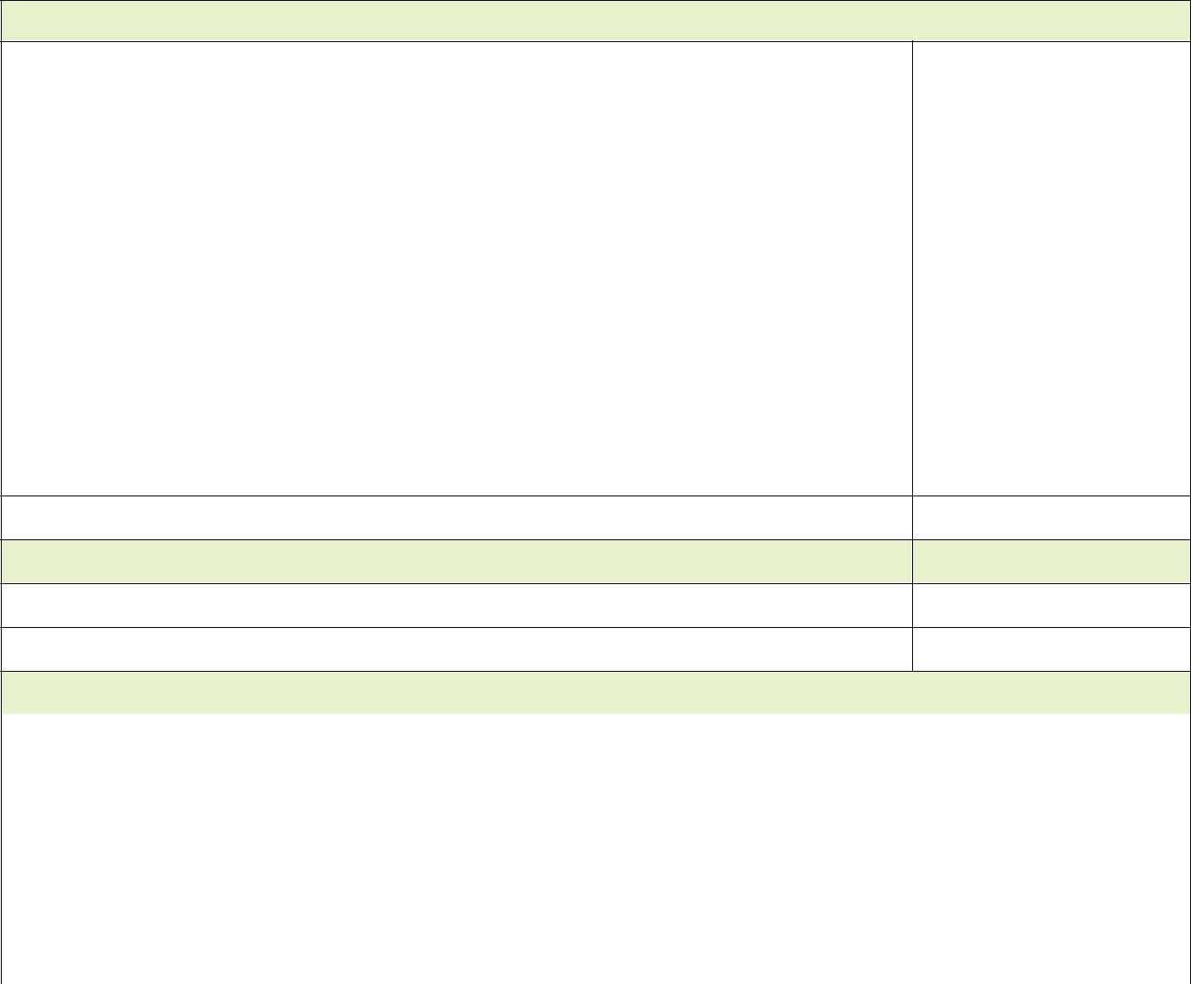
Processing data

 | Graphs data collected from the investigation (if applicable):
 | x provides appropriate graph title
 | x | labels axes correctly |  |  | 1–5
 | x includes appropriate units of measurement
 | x | plots data correctly
 | x draws the appropriate type of graph.
 |  | Subtotal | 5
 | Analysing data
 | Describes relationships or trends in the results. |  |  |  | 1–2
 | Refers to specific data when describing relationships or trends. |  | 1
 | Compares the results to their prediction. |  | 1

Subtotal

4

Explains the relationships or trends in the results using science ideas.

1–2

Subtotal

2

Evaluating

 | Identifies difficulties experienced when conducting the investigation. |  | 1–2
 | May include reference to, but not limited to: quality of the data, correct use of
 | equipment, choice of equipment.
 | Makes suggestions to overcome the difficulties described, including ways to improve |  | 1–2
 | the quality of the data.
 | Subtotal | 4
 | Total |  | 32

Science | Year 8 | Investigation 8

